PRESS RELEASE
EDWARD lehman- ONE OF ONLY TWO LAWYERS IN WHO’S WHO LEGAL, FRANCHISING IN CHINA
Beijing, China – March 11, 2008 – Edward Lehman of Lehman, Lee & Xu was recently listed as one of only two lawyers for franchising issues in China by Who’s Who Legal. Edward Lehman, who has over two decades of legal experience in China has represented a large number of international franchisers in their expansion efforts in China.

Mr. Lehman not only provides franchise advice, but advises on a wide range of issues relevant to international franchisors, including trademarks, patents, business methods, international structuring, franchise contracts, and licensing. Additionally, Mr. Lehman is listed as a Trademark expert by Who's Who Legal.

“Since 1996 Who's Who Legal has identified the foremost legal practitioners in 29 areas of business law. In total, this site features over 9,000 of the World’s leading private practice lawyers from over 100 national jurisdictions.”
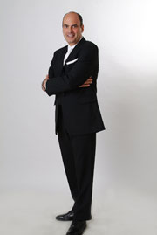
To learn more about Who’s Who Legal, please visit their website at www.whoswholegal.com.

To learn more about the firm, please visit the firm’s website at www.lehmanlaw.com.

Lehman, Lee & Xu is a prominent Chinese corporate law firm and trademark and patent agency with offices in Beijing, Shanghai, Shenzhen, Hong Kong, Macau, and Mongolia. The firm is managed by Mr. Edward Lehman who is a long-time China resident, and is recognized as a leading expert on corporate law with 20 years of practice experience in Mainland China.

